Oak Ridge Electrical Joint Apprenticeship and Training
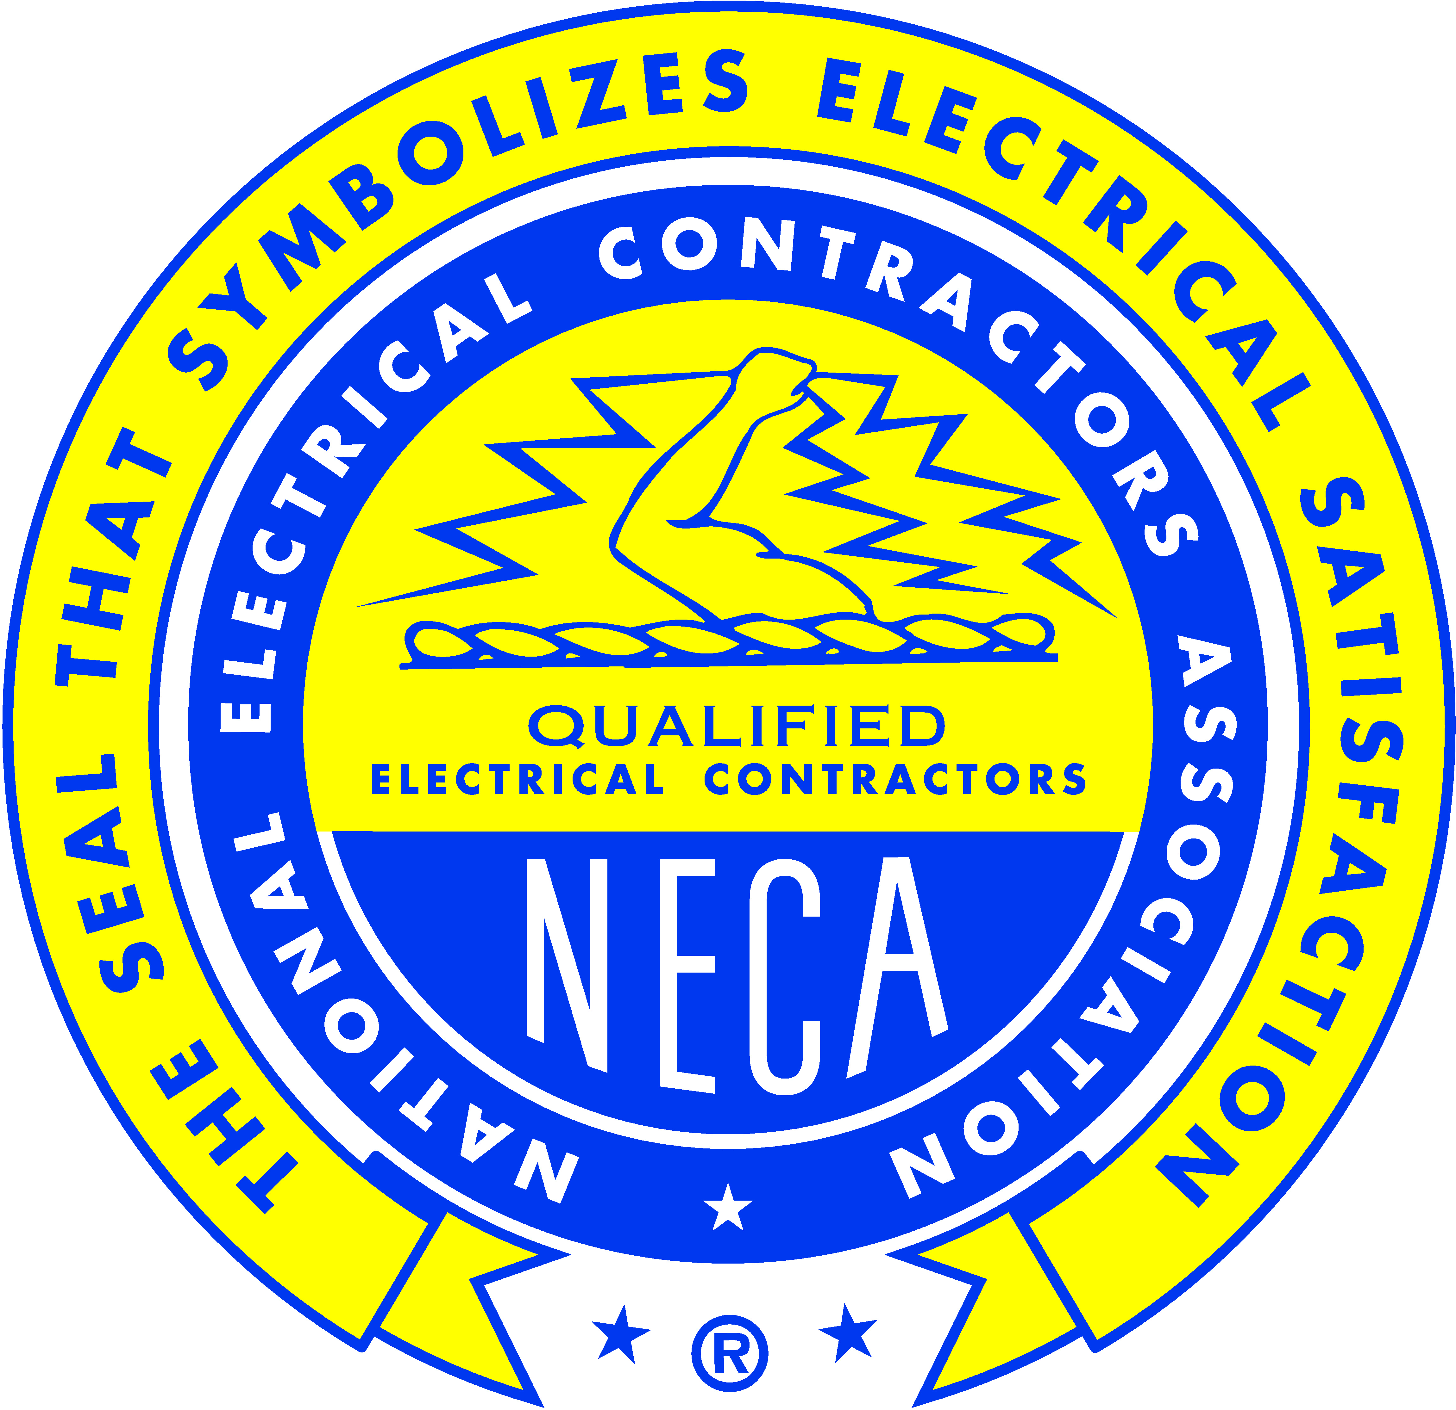
138 North Lincoln Circle
Post Office Box 4968
Oak Ridge, Tennessee 37831-4968
Phone: 865.483.9955
eFax: 1.865.272.4304

APPLICANT RE-INTERVIEW REQUEST FORM

Name Date

I understand that after 6 months from the date of initial interview with the Oak Ridge Electrical JATC, if I have gained at least 450 hours of work experience in the electrical construction industry, or successfully completed two or more post-secondary, trade related classes, I may request a re-interview with the JATC. Therefore, I am at this time requesting that the JATC consider the documentation I have submitted to determine if a re-interview is warranted.

Work Experience I Have Gained (Documentation Attached):

Additional Related Education & Training I Have Gained (Documentation Attached):

My signature below indicates I fully understand that if a re-interview is granted, the resulting interview score will supersede any previous scores.

Applicant Signature

-TO BE COMPLETED BY THE JATC-

Application Number Date of Original Interview

